# CDInterfaceModule Integration testing

## Overview

To provide confidence that a release of CDInterfaceModule meets its requirements and works as expected a number of Integration Tests should be carried out.

This is especially important prior to a new Operational release, although helps to ensure bugs haven’t crept in at any point in a development cycle.

### Test Coverage

On a given server it may not be possible to run all Actions and Options, for example a server with only a single drive would not be able to utilize the recorderIndex option in a meaningful way.

Because of this there is a minimum set of tests listed here, those which will complete successfully on a single drive server. Additional tests that should have been run on at least one compatible system are listed separately.

The tests are presented in the form of a table, so that a copy of this document can be used to record test results.

## Prior to a test run

Install CDInterfaceModule as described in the Support guide.

## Test Run Details

Record the details of the test run in the following table.

|  |  |  |  |
| --- | --- | --- | --- |
| Date | Server | Tester | Notes |
|  |  |  |  |

## Tests

|  |  |  |  |  |  |  |  |  |
| --- | --- | --- | --- | --- | --- | --- | --- | --- |
| Test | Command | | | Start Condition | Expected | | | Pass/Fail |
| Version | -version | | |  | Version displayed | | |  |
| Help | -help | | |  | Help text displayed | | |  |
| No arguments |  | | |  | Error and Help page | | |  |
| List Drives | -list | | |  | A list of drives | | |  |
| Eject tray | -ejecttray | | | Tray closed | The tray should eject | | |  |
| Drive Letter | -driveletter | | |  | The drive letter | | |  |
| Drive Status | -getdrivestate | | | No media | NO_DISC | | |  |
| Drive Status | -getdrivestate | | | Blank CDR | BLANK_CD | | |  |
| Drive Status | -getdrivestate | | | CD | NON_WRITEABLE_DISC | | |  |
| Drive Status | -getdrivestate -production | | | Blank CDRW | INVALID_MEDIA | | |  |
| Drive Status | -getdrivestate -onlysingleline | | | Blank CDRW | BLANK_CD only | | |  |
| Drive Status | -getdrivestate | | | Blank CDRW | BLANK_CD | | |  |
| Write to media | | -writetomedia <dir> -cdlabel <label> -production | Blank CDR | | | Contents of <dir> copied to media and label applied |  | |
| Write to media | -writetomedia <dir> -cdlabel <label> | | | Blank CDRW | Contents of <dir> copied to media and label applied | | |  |
| Write to media | -writetomedia <dir> -cdlabel <label> -noejectafterwrite | | | Blank CDRW | Tray is not ejected after write | | |  |
| Write to media | -writetomedia <dir> -cdlabel <label> -verbose | | | Blank CDRW | Additional step by step information should be displayed | | |  |
| Media Type | -getmediatype | | | CDRW | The type of media | | |  |
| Media Type List | -getmediatypelist | | |  | A list of media types | | |  |

## Non-Essential tests

If you have access to a server with 2 drives these test should be run.

The CDInterface -list Action should produce output similar to the following

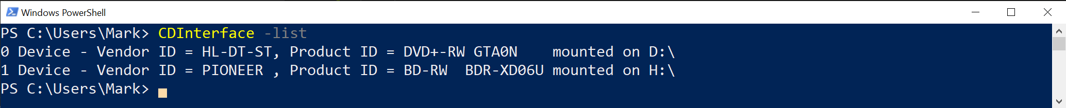

If you enable verbose output, with the -verbose Option you should see full drive information in the internal format, similar to the following

By adding the -verbose option the output also shows if the media is physically blank, i.e. for erasable media, it has never been written to.

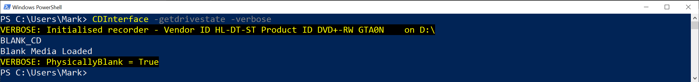

Run the Essential tests for Drive Status and Write to media passing the additional -recordIndex 1 option and confirm the same results are targeted at the second drive.

### Invoking from Java

Run the example Java application to make sure that CDInterface can be invoked from Java. See the Developer Guide for more information on the example java application.